Research Article
Análisis estadístico de la diversidad microbiana a distintos niveles taxonómicos en datos metagenómicos de alta dimensión
Statistical Analysis of Microbial Diversity Across Taxonomic Levels in High-Dimensional Metagenomic Data
Análise estatística da diversidade microbiana em diferentes níveis taxonômicos em dados metagenômicos de alta dimensão

Paula Camila Silva Gómez¹
Nelly Sélem Mojica²
José Alexander Fuentes Montoya³

ABSTRACT
Metagenomic data analysis poses a major challenge for Data Science due to the high volume, complexity, and compositional nature of the information generated by high-throughput sequencing technologies. In this context, the present study proposes a statistical and bioinformatic analysis pipeline for characterizing the rhizosphere microbiome of Fragaria × ananassa crops, aiming to identify patterns associated with plant health status and to evaluate the potential of metagenomic data to support analysis and decision-making processes in agriculture.
The study was conducted using metagenomic data provided by the company Solena Ag. After a quality-control and preprocessing stage, 53 samples (35 healthy and 18 unhealthy) were analyzed using reproducible tools implemented in R and Bash. The methodological pipeline integrated data conversion to the BIOM format, handling through Phyloseq, exploratory analysis, calculation of alpha diversity indices (Chao1, Shannon, and Simpson), beta diversity metrics (Bray-Curtis, Jaccard, Manhattan, Euclidean, and Jensen-Shannon), taxonomic exploration at different hierarchical levels, and statistical hypothesis testing using Student's t-test and the Mann–Whitney test.
The results show that healthy plants tend to exhibit greater microbial diversity and a more balanced community, while unhealthy plants exhibit a higher presence of microorganisms potentially associated with disease. Nevertheless, the overall differences between both groups did not reach statistical significance for the general diversity metrics, which evidences the inherent complexity of agricultural microbiomes and the need to incorporate analytical models with greater descriptive and predictive capacity.
As a main contribution, this work integrates Data Science, statistical, and bioinformatic tools into a reproducible pipeline for metagenomic data analysis, providing a methodological basis for future research aimed at developing machine learning models and decision-support systems based on microbial biomarkers applied to precision agriculture.
Keywords: metagenomics; data science; rhizosphere microbiome; alpha diversity; beta diversity; Fragaria × ananassa; bioinformatics; hypothesis testing.
RESUMEN
El análisis de datos metagenómicos representa un desafío para la Ciencia de Datos debido al alto volumen, complejidad y naturaleza composicional de la información generada por las tecnologías de secuenciación masiva. En este contexto, el presente trabajo propone un flujo de análisis estadístico y bioinformático para la caracterización del microbioma rizosférico de cultivos de Fragaria × ananassa, con el objetivo de identificar patrones asociados al estado sanitario de las plantas y evaluar el potencial de los datos metagenómicos para apoyar procesos de análisis y toma de decisiones en agricultura.
El estudio se desarrolló a partir de datos metagenómicos proporcionados por la empresa Solena Ag. Después de un proceso de control de calidad y preprocesamiento, se analizaron 53 muestras (35 saludables y 18 no saludables) utilizando herramientas reproducibles implementadas en R y Bash. El flujo metodológico integró conversión de datos al formato BIOM, manejo mediante Phyloseq, análisis exploratorio, cálculo de índices de diversidad alfa (Chao1, Shannon y Simpson), diversidad beta (Bray-Curtis, Jaccard, Manhattan, Euclidiana y Jensen-Shannon), exploración taxonómica en distintos niveles jerárquicos y pruebas estadísticas de hipótesis mediante t de Student y Mann–Whitney.
Los resultados muestran que las plantas saludables presentan una tendencia hacia una mayor diversidad microbiana y una comunidad más equilibrada, mientras que las plantas no saludables exhiben una mayor presencia de microorganismos potencialmente asociados con enfermedad. No obstante, las diferencias globales entre ambos grupos no alcanzaron significancia estadística para las métricas generales de diversidad.
Palabras clave: metagenómica; ciencia de datos; microbioma rizosférico; diversidad alfa; diversidad beta; Fragaria × ananassa; bioinformática; pruebas de hipótesis.
INTRODUCTION
Metagenomic data analysis is, in essence, a computer science problem: it involves representing, storing, processing, and extracting patterns from very high-dimensional data structures under scalability and reproducibility constraints. Metagenomics —the study of genetic material recovered directly from environmental samples, without prior cultivation of the microorganisms— is one of the domains where this computational perspective is most evident. High-throughput sequencing technologies produce sparse count matrices on the order of thousands of taxa per sample, whose efficient manipulation depends on specialized data structures, sequence-classification algorithms, and workflows designed according to software-engineering criteria: modularity, traceability, and reproducibility (Marchesi & Ravel, 2015).
From an algorithmic standpoint, the taxonomic assignment of reads —the stage that transforms millions of raw sequences into a count matrix— is solved through efficient exact k-mer matching against indexed databases, such as those implemented in Kraken (Wood & Salzberg, 2014), followed by a probabilistic refinement of abundances with Bayesian re-estimation methods such as Bracken (Lu et al., 2017). The result is a high-dimensional count matrix of compositional nature: the relative abundances of each sample are constrained to the simplex (they sum to a constant), which invalidates the naive use of the Euclidean distance and of many classical statistical assumptions, and imposes the use of specific transformations and dissimilarity metrics. These features —sparsity, high dimensionality, compositionality, and volume— place metagenomic analysis at the intersection of data science, computational statistics, and bioinformatics.
The rhizosphere microbiome —the community of bacteria, archaea, fungi, and other microorganisms that inhabit the interface between the root and the soil— plays a central role in plant nutrition, resistance to phytopathogens, and crop resilience under adverse environmental conditions (Berendsen et al., 2012; Compant et al., 2019). Numerous studies have shown that the composition and structure of this microbial community are closely related to the plant's health status, which has driven the search for microbial biomarkers capable of anticipating or accompanying the diagnosis of disease processes (Siegieda et al., 2024).
Strawberry (Fragaria × ananassa) is one of the most commercially and nutritionally relevant fruit crops worldwide, but its production is particularly sensitive to fungal and bacterial soil diseases, as well as to agricultural practices and environmental conditions. In recent years, several studies have documented consistent taxonomic differences between healthy and unhealthy strawberry rhizospheres: genera such as Udaeobacter and Solibacter, together with the family Nitrosomonadaceae, tend to be more abundant in unhealthy rhizospheres, whereas taxa such as Tepidisphaerales and Hydrocarboniphaga are associated with healthy conditions (Siegieda et al., 2024). Likewise, consortia of plant growth-promoting rhizobacteria (PGPR), such as Bacillus subtilis, Bacillus amyloliquefaciens, and Pseudomonas monteilii, have been reported to favorably modify the soil microbiome and fruit quality (Nam et al., 2023), whereas phytopathogenic microorganisms such as Fusarium spp., Phytophthora spp., or Botrytis cinerea have been recurrently linked to wilting and root-rot processes in this crop (Yang et al., 2020).
These findings raise an underlying methodological question: to what extent do conventional statistical tools —diversity indices and hypothesis-based inference— allow the differences observed at the taxonomic level to be formally captured and validated, considering the moderate sample size, the high dimensionality, and the compositional nature typical of agricultural metagenomic studies? Answering this question requires not only computing the conventional alpha and beta diversity indices, but also evaluating their discriminant capacity through parametric and non-parametric hypothesis tests, and exploring the structure of the data at different hierarchical levels of the taxonomy, from domain to species.
In this context, the present work aims to design and implement a reproducible computational workflow —conceived as a modular software artifact— for the statistical analysis of the microbial diversity of the rhizosphere microbiome of strawberry crops, using metagenomic data provided by the AgTech company Solena Ag. Specifically, it seeks to: (i) establish an algorithmic procedure for quality control and preprocessing of the taxonomic-classification data generated with Kraken; (ii) characterize the alpha and beta diversity of the microbial communities associated with healthy and unhealthy plants, both at the global level and at different taxonomic levels (kingdom, phylum, family, genus, and species); (iii) statistically contrast the observed differences through parametric (Student's t-test, with equal and unequal variances) and non-parametric (Mann–Whitney) hypothesis tests; and (iv) discuss the potential and limitations of this workflow as a computational basis for developing machine learning models and decision-support systems in precision agriculture based on microbial biomarkers.
The contribution of this work is therefore both methodological and computational: in addition to characterizing the strawberry microbiome, it provides a reproducible, versioned, and documented pipeline —whose scripts are organized modularly by stage— that can be re-executed on new datasets or crops, and that constitutes an engineering foundation on which to build automatic classifiers of plant health status.
Unlike studies that limit themselves to reporting descriptive abundance differences between groups, this work emphasizes the formal statistical validation of such differences. As will be shown below, the absence of statistical significance at the global level does not invalidate the existence of biologically relevant patterns at finer taxonomic levels, a methodological distinction with direct implications for the design of future studies and predictive models in this domain.
METHODOLOGY
The proposed workflow was designed as a modular computational pipeline organized into five sequential stages: preprocessing and quality control, computation of alpha diversity indices, computation of beta diversity indices, taxonomic exploration at different hierarchical levels, and statistical validation through hypothesis tests. The entire analysis was implemented reproducibly using BASH for orchestration and data formatting, and R/RStudio, with the Phyloseq package as the central component, for statistical analysis and visualization.
Computational architecture, data structures, and reproducibility
From a software-engineering perspective, the pipeline was implemented as a collection of numbered, independent scripts (one module per stage), where each module explicitly loads its input, performs a well-delimited transformation, and persists its outputs (figures and intermediate tables). This modular decomposition favors traceability, debugging, and selective re-execution, and allows the analysis to be treated as a reproducible, versionable artifact rather than as a sequence of unrepeatable interactive operations.
The central data structure is the Phyloseq object (McMurdie & Holmes, 2013), a container that coherently integrates four components: the count matrix (taxon × sample), the taxonomy table (which encodes the hierarchy Kingdom → Phylum → Class → Order → Family → Genus → Species), the sample metadata and, when available, the phylogenetic tree. The highly sparse count matrix is stored and exchanged through the BIOM format (McDonald et al., 2012), a binary/JSON standard optimized for large biological observation matrices. The pipeline operations —agglomeration by taxonomic rank, transformation to relative abundances, and computation of pairwise sample distance matrices— have well-characterized computational costs; in particular, the computation of beta diversity is quadratic in the number of samples (on the order of O(n²·p) for n samples and p taxa), which motivates the filtering and agglomeration decisions adopted to keep the analysis tractable.
To ensure reproducibility, a common random seed was fixed for all stochastic stages (for example, the NMDS ordinations), all paths were resolved relative to the project root, and the exact execution environment (versions of R and of the packages) was recorded. The complete code is distributed together with this work as an R computation directory organized by stage (00_setup, 01_preprocesamiento, 02_diversidad_alfa, 03_diversidad_beta, 04_exploracion_taxonomica, and 05_pruebas_hipotesis), accompanied by an orchestrator script and documentation, so that all reported results and figures can be regenerated with a single invocation.
Study design and data source
An observational, cross-sectional, and exploratory study was carried out on secondary metagenomic data from the rhizosphere of strawberry crops (Fragaria × ananassa), provided by the company Solena Ag, an agricultural biotechnology (AgTech) company focused on the analysis and improvement of the soil microbiome through molecular data and artificial intelligence. The sequences were delivered in FASTA format, and the results of their taxonomic classification —previously obtained through the Kraken classifier (Wood & Salzberg, 2014)— were stored in JSON files, together with the metadata of each sample, including the variable of interest "Treatment", with two levels: healthy and unhealthy (wilted). Unlike amplicon-based workflows (16S rRNA or ITS) that typically rely on platforms such as QIIME 2 (Bolyen et al., 2019) together with curated reference databases such as SILVA (Quast et al., 2013), this study started from a shotgun-type taxonomic classification generated with Kraken over the NCBI taxonomy, which conditions the preprocessing decisions described below.
Preprocessing and quality control
The original dataset comprised 58 samples: 18 labeled as unhealthy and 40 as healthy. Before any diversity analysis, a quality-control process was carried out based on a summary table provided by Solena (based on fastp and on the Kraken output), which reported, for each sample, the number of reads before and after quality filtering, the percentage of bases with Phred quality above 30 before and after filtering, the number of low-quality reads, the number of reads discarded for containing ambiguous bases ("N"), the number of reads discarded for insufficient length, the duplication percentage, the average read length (R1 and R2), and the percentage of effectively classified reads.
A minimum threshold of 25 million reads after quality filtering was established as an exclusion criterion. Under this criterion, five samples were identified and removed (MP2079, MP2080, MP2088, MP2109, and MP2137); in particular, sample MP2088 retained only two reads after filtering, which illustrates the need for this control to avoid unreliable diversity estimates based on insufficient sequencing depths. After applying the filter, the dataset consisted of 53 samples: 35 healthy and 18 unhealthy, a proportion that remained constant throughout all subsequent analysis.
The filtered data were structured as a Phyloseq object (McMurdie & Holmes, 2013), which integrates up to four components: the abundance table (taxon × sample count matrix), the taxonomy table, the sample metadata and, when available, the phylogenetic tree. Beforehand, the Kraken results in JSON format were converted to the standard BIOM format (Biological Observation Matrix; McDonald et al., 2012), which allowed efficient and interoperable storage of the abundance matrices and their associated metadata.
Alpha diversity indices
Alpha diversity quantifies species richness and evenness within a sample or community. Three complementary indices were computed on the filtered Phyloseq object: Chao1, a non-parametric estimator of total species richness based on the count of singletons and doubletons (Chao, 1984), particularly robust to rare species and small samples; the Shannon index (H' = −Σ pᵢ ln pᵢ), which simultaneously weighs richness and evenness; and the Simpson index (D = 1 / Σ pᵢ²), sensitive to the dominance of the most abundant species.
These indices were computed at two moments: first, on the raw data and on the quality-filtered data, in order to evaluate the effect of quality control on the clarity of the biological signal; and second, on taxonomic subsets obtained by partitioning the Phyloseq object by kingdom (Bacteria and Eukaryota) and, within each kingdom, by agglomerating the taxa (agglomeration function with a 10 % threshold) at the phylum, family, genus, and species levels, with the aim of exploring whether taxonomic resolution influences the ability to discriminate between groups.
Beta diversity indices
Beta diversity evaluates how similar or different microbial communities are between pairs of samples. Prior to its computation, absolute abundances were transformed into per-sample relative abundances (Phyloseq count-transformation function), in order to correct for differences in sequencing depth between metagenomes. On these data, five distance or dissimilarity metrics were computed: Bray-Curtis (Bray & Curtis, 1957), Jaccard, Euclidean, Manhattan, and the Jensen-Shannon divergence, and the results were visualized through non-metric multidimensional scaling (NMDS). As with alpha diversity, this analysis was replicated both at the whole-community level and in the taxonomic subsets by kingdom, phylum, family, genus, and species.
Multilevel taxonomic exploration
Bar plots of absolute and relative abundance were generated, with samples on the horizontal axis and abundance on the vertical axis, visually differentiating between healthy and unhealthy samples. This analysis was carried out hierarchically: first at the level of the whole dataset (phylum), and subsequently independently for the Bacteria and Eukaryota subsets, at the phylum, family, genus, and species levels, in order to identify taxa whose relative abundance differed in a visually consistent way between the two health states.
Hypothesis tests
To formally contrast the differences observed descriptively, null hypotheses of equality between the healthy and unhealthy groups were posed against alternative hypotheses of difference, using the Shannon index as the response variable. Student's t-test was applied for the comparison of two population means with small samples, under two alternative assumptions: equal variances and unequal variances (Welch's test; Welch, 1947), both at the whole-community level and restricted to the genus Fusarium, given its documented relevance as a strawberry phytopathogen. As a non-parametric complement —and given that the normality assumption could not always be guaranteed—, the Wilcoxon signed-rank test in its two independent-sample version, equivalent to the Mann–Whitney U test (Mann & Whitney, 1947; Wilcoxon, 1945), was applied to compare the central tendency of the Shannon index distributions between both groups. In all cases, a significance level of α = 0.05 was used.
Normalization, complementary analysis, and reproducibility
In addition to the transformation to relative abundances, the normalization of the count table with edgeR (Robinson et al., 2010) and rarefaction were evaluated as strategies for equalizing sequencing depth. As a complementary exploration, co-occurrence networks between samples were generated from the Jaccard distance, to inspect whether connectivity alone revealed a separation between health states.
The taxonomic classification of the reads was previously performed by Solena Ag using Kraken (Wood & Salzberg, 2014), with Bayesian re-estimation of abundances through Bracken (Lu et al., 2017). The complete data flow followed the sequence: FASTA (raw sequences) → JSON (Kraken taxonomic classification) → BIOM (McDonald et al., 2012) → Phyloseq object (McMurdie & Holmes, 2013). All the preprocessing, index-computation, and statistical-testing code was documented in reproducible R Markdown notebooks and BASH scripts, which allows each of the results reported in the following section to be audited and replicated.
RESULTS
Effect of quality control on alpha diversity
Before applying the quality filter, the alpha diversity observed across the four indices (observed richness, Chao1, Shannon, and Simpson) was practically indistinguishable between the healthy and unhealthy groups, due to the influence of a small number of samples with extremely low sequencing depths, which visually compressed the scale of all the plots (Figure 1A). After removing the five low-quality samples, the separation between groups became considerably clearer (Figure 1B): the healthy samples showed a trend toward greater diversity, particularly evident in the Chao1 index, which, being less sensitive to the noise introduced by low-confidence singletons and doubletons, allowed the richness difference between groups to be appreciated more sharply. It should be noted that, although this difference was visually perceptible, its magnitude was not markedly large, which anticipated the inconclusive results of the hypothesis tests presented later.
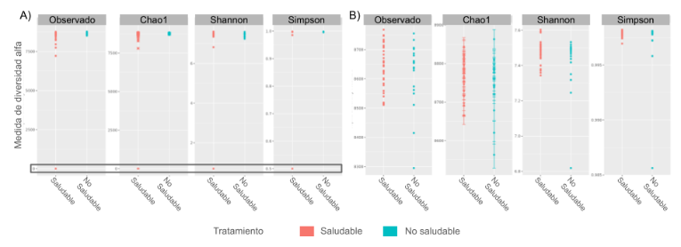
Figure 1. Alpha diversity (observed richness, Chao1, Shannon, and Simpson) in healthy and unhealthy samples. A) Before quality filtering, the scale is dominated by low-depth samples and does not allow differences between groups to be distinguished. B) After quality filtering (25-million-read threshold), a trend toward greater diversity in the healthy samples is more clearly appreciated, especially in the Chao1 index. Own elaboration based on data from Solena Ag.
Global beta diversity
The five beta diversity metrics computed —Bray-Curtis, Jaccard, Euclidean, Manhattan, and Jensen-Shannon— showed a consistent pattern: the NMDS ordinations revealed a broad overlap between healthy and unhealthy samples, with none of the metrics achieving a clear separation between groups (Figure 2). This result suggests that, at the whole-community level, global compositional dissimilarity is not by itself sufficient to discriminate the plant's health status, and motivated the complementary analysis in more specific taxonomic subsets described below.
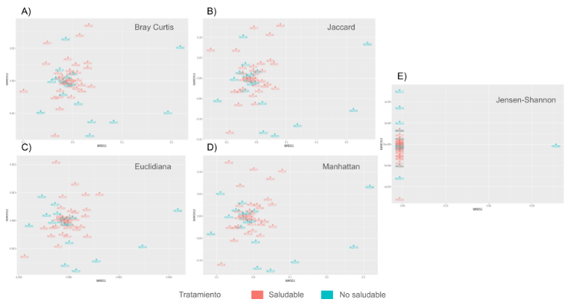
Figure 2. NMDS ordinations of beta diversity for five distance/dissimilarity metrics. A) Bray-Curtis. B) Jaccard. C) Euclidean. D) Manhattan. E) Jensen-Shannon. In none of the five metrics is a sharp separation observed between healthy (red) and unhealthy (turquoise) samples, indicating a broad overlap in the global microbial composition between both groups. Own elaboration based on data from Solena Ag.
Sequencing depth by group
Healthy samples (N = 35) presented, on average, a higher number of reads than unhealthy samples (N = 18). This difference in sequencing depth between groups must be considered when interpreting diversity comparisons, since richness estimators can be sensitive to sampling depth, even though the transformation to relative abundances used in the beta diversity analysis partially mitigates this effect.
General taxonomic composition
At the kingdom level, the filtered dataset consisted of 8,822 OTUs classified as Bacteria and 181 OTUs classified as Eukaryota, which confirms the bacterial predominance characteristic of soil and rhizosphere microbiomes. At the phylum level, considering the full set of samples, Actinobacteria and Proteobacteria were identified as the phyla with the highest relative abundance (Figure 3), a pattern consistent with the literature on rhizospheres of fruit crops (Compant et al., 2019).
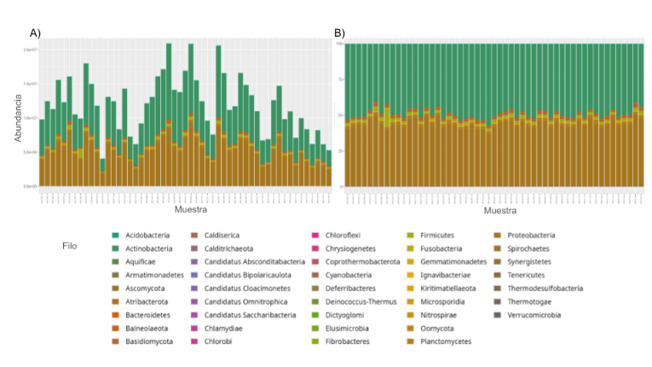
Figure 3. Abundance of microorganisms at the phylum level in the 53 samples analyzed. A) Absolute abundance (number of reads assigned to each phylum). B) Relative abundance (percentage). Actinobacteria and Proteobacteria dominate the taxonomic composition of the complete dataset. Own elaboration based on data from Solena Ag.
Diversity and composition by taxonomic level
Disaggregating the analysis by kingdom and by taxonomic level made evident patterns that were not discernible at the whole-community level. Within the Eukaryota subset, a lower relative abundance of the phylum Oomycota was observed in the unhealthy samples relative to the healthy ones, as well as a specific decrease of the family Peronosporaceae in the unhealthy samples. At finer levels (genus and species), the taxonomic exploration identified eukaryotic taxa —among them Fusarium and Phytophthora— with a higher relative presence in the unhealthy samples, consistent with their documented role as strawberry phytopathogens (Yang et al., 2020).
Within the Bacteria subset, the phylum-level analysis showed that healthy samples tend to be dominated by Actinobacteria and Proteobacteria, whereas the unhealthy samples present a distinct internal structure, with a higher relative contribution of other secondary phyla. Delving into the family and genus levels, differentiating taxa were identified, among others, the family Streptomycetaceae and the genus Streptomyces, as well as the family Paenibacillaceae, the genus Paenibacillus and, at the species level, Paenibacillus polymyxa —a microorganism widely documented as a plant growth-promoting rhizobacterium and biocontrol agent—, whose relative presence showed a more defined pattern in the healthy samples (Figure 4). Consistent with previous reports in strawberry, the taxonomic exploration also identified a higher relative presence of genera with pathogenic potential, such as Ralstonia, in unhealthy samples, and of beneficial genera, such as Pseudomonas and Bacillus, in healthy samples (Nam et al., 2023; Siegieda et al., 2024).
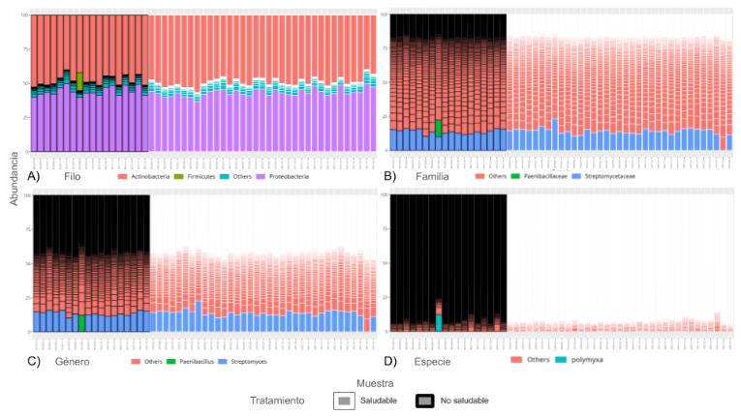
Figure 4. Bacterial composition in healthy samples (gray box) and unhealthy samples (black box) at different taxonomic levels, after a 10 % agglomeration to improve visualization. A) Phylum: predominance of Actinobacteria and Proteobacteria. B) Family: higher relative contribution of Streptomycetaceae and differentiated presence of Paenibacillaceae. C) Genus: Streptomyces and Paenibacillus as distinctive taxa. D) Species: differentiated presence of Paenibacillus polymyxa. Own elaboration based on data from Solena Ag.
Regarding diversity, both alpha and beta, computed within each taxonomic level, the alpha diversity of Eukaryota revealed a more balanced microbiota in the healthy plants versus a greater dominance of potentially pathogenic taxa in the unhealthy ones, while the alpha diversity of Bacteria showed a similar pattern, with greater diversity and balance in the healthy samples at all evaluated taxonomic levels. Regarding beta diversity by taxonomic level, none of the partitions (phylum, family, genus, species) achieved a complete separation between groups; however, the Bray-Curtis metric showed more evident compositional differences precisely at the finer levels (genus and species), which reinforces the value of taxonomic disaggregation over the whole-community analysis as a strategy for identifying candidate biomarkers.
Hypothesis tests
Student's t-test on the Shannon index at the whole-community level did not provide sufficient statistical evidence to reject the null hypothesis of equal means between the healthy and unhealthy groups: assuming equal variances, the p-value was greater than 0.05, and assuming unequal variances (Welch's test), the p-value was 0.1501. That is, although the healthy samples visually showed a higher average diversity, this difference did not reach statistical significance at the considered level α = 0.05.
In contrast, when restricting the analysis to the genus Fusarium, both versions of the t-test (equal and unequal variances) showed statistically significant differences (p < 0.05) between the healthy and unhealthy groups, with the healthy group presenting a broader distribution and a higher average diversity associated with this genus (Figure 5). This result, restricted to a specific taxon, contrasts with the non-significant result obtained at the whole-community level, and illustrates that signals associated with particular taxa can be diluted when aggregated into indices computed over the entire community.
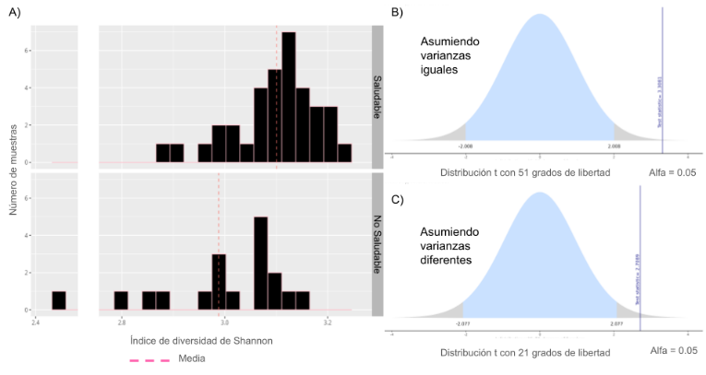
Figure 5. Student's t-test on the Shannon index restricted to the genus Fusarium. A) Distribution of the Shannon index values in the healthy and unhealthy groups, with the mean of each group indicated. B) t distribution under the equal-variances assumption (computed t = 3.31, df = 51); the observed statistic falls within the rejection region (α = 0.05). C) t distribution under the unequal-variances assumption (computed t = 2.71, df = 21); the observed statistic also falls within the rejection region. Own elaboration based on data from Solena Ag.
Finally, the Wilcoxon Mann–Whitney rank test on the Shannon index at the whole-community level yielded a statistic W = 376 and a p-value = 0.2586 (Figure 6), with a 95 % confidence interval for the difference in central location between (−0.0124, 0.0561) and a point estimate of that difference of 0.017 units in favor of the healthy group. Since the confidence interval includes zero, there is insufficient statistical evidence to reject the null hypothesis of equal central location of the Shannon index distributions between both groups. This non-parametric result corroborates the conclusion obtained with the t-test: with the available sample size, it was not possible to establish a globally statistically significant difference in Shannon diversity between healthy and unhealthy plants, whereas the specific signal of the genus Fusarium did turn out to be significant.
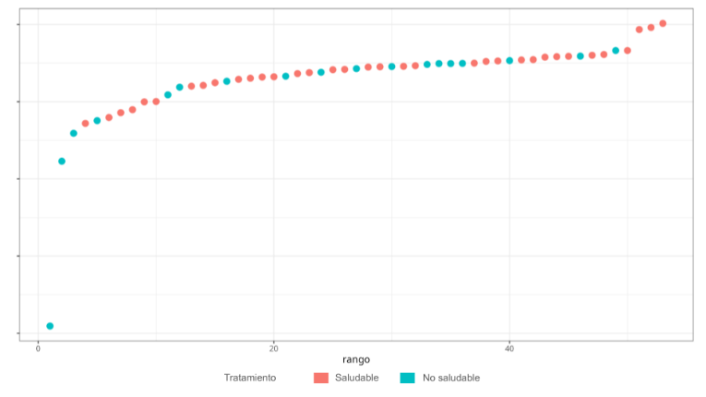
Figure 6. Distribution of the combined ranks of the Shannon index in the Wilcoxon Mann–Whitney test. The values of the healthy (red) and unhealthy (turquoise) groups appear mixed throughout the whole range, consistent with the absence of a statistically significant difference (W = 376; p = 0.2586). Own elaboration based on data from Solena Ag.
DISCUSSION AND CONCLUSIONS
The results of this work show a pattern that is frequent in the statistical analysis of agricultural microbiomes: the existence of consistent biological trends and plausible differentiating taxonomic patterns that, nevertheless, do not always reach statistical significance when evaluated through aggregated indices at the whole-community level. Healthy plants showed, consistently across the different analyses, greater diversity and greater microbial balance, both in the global alpha diversity and in that computed by taxonomic level, whereas unhealthy plants exhibited a higher relative presence of taxa potentially associated with disease, such as Fusarium, Phytophthora, and Ralstonia, and a lower presence of taxa such as Oomycota, Peronosporaceae, Pseudomonas, Bacillus, and Paenibacillus. However, neither the global alpha diversity (Chao1, Shannon, Simpson) nor the global beta diversity (Bray-Curtis, Jaccard, Euclidean, Manhattan, Jensen-Shannon) allowed a statistically robust separation between groups, and the hypothesis tests on the Shannon index at the whole-community level —both Student's t-test and the Mann–Whitney test— did not reach significance at the level α = 0.05.
This apparent contradiction between the descriptive trend and the lack of global statistical significance admits several non-exclusive explanations. First, the compositional and high-dimensional nature of metagenomic data implies that a single index, computed over thousands of taxa simultaneously, can dilute biological signals that are strong only in a reduced subset of taxa —as evidenced by the genus Fusarium, whose diversity difference was indeed significant when analyzed in isolation. Second, the sample size and imbalance (35 healthy samples versus 18 unhealthy ones), together with the observed difference in sequencing depth between groups, reduces the statistical power available to detect moderate differences. Third, agricultural rhizosphere microbiomes are subject to multiple sources of variability not controlled in this study —variation between crop batches, management practices, edaphoclimatic conditions— which can introduce additional noise over the signal strictly associated with the plant's health status.
These findings are consistent with the recent literature on strawberry microbiomes, which reports specific taxonomic differences between healthy and unhealthy rhizospheres —including beneficial taxa such as Pseudomonas monteilii, Bacillus subtilis, and Bacillus amyloliquefaciens (Nam et al., 2023), and dysbiosis biomarker taxa such as Udaeobacter, Solibacter, and Nitrosomonadaceae (Siegieda et al., 2024)—, without this necessarily implying globally statistically robust diversity differences. Taken together, these results reinforce the idea that the health status of a crop is not uniformly reflected across the entire microbial community, but in specific taxonomic subsets, which methodologically supports the multilevel exploration strategy adopted in this work over an analysis limited to the whole community.
From the perspective of precision agriculture, the identification of candidate biomarker taxa —positive, such as Pseudomonas, Bacillus, and Paenibacillus polymyxa, and negative, such as Fusarium, Phytophthora, and Ralstonia— constitutes a quantitative input of practical value for the design of early-monitoring systems of soil health status, as well as for the rational selection of microorganisms with potential as bioinputs or biocontrol agents. The main contribution of this work, however, does not lie in an isolated taxonomic finding, but in the computational artifact developed: a reproducible, modular, and versioned pipeline —integrating BASH, R, the BIOM format, and Phyloseq— capable of systematically and traceably executing quality control, the computation of alpha and beta diversity, multilevel taxonomic exploration, and statistical hypothesis validation on agricultural metagenomic data. Being organized by stages with explicit inputs and outputs, this workflow can be reused directly on new datasets or crops and, above all, functions as the feature-engineering layer on which to build automatic classifiers: the abundance matrices agglomerated by taxonomic level that the pipeline produces are precisely the type of input representation required by supervised machine learning models.
This study presents limitations that must be considered when interpreting its results. The design is cross-sectional and is based on a single crop and a single data source, which limits generalization to other agroecological contexts. The sample size, while adequate for an exploratory analysis, is moderate and imbalanced between groups for high-statistical-power hypothesis tests, and no formal corrections for multiple comparisons were applied when evaluating several taxonomic levels simultaneously, so the patterns identified at those levels should be interpreted as hypotheses to be confirmed rather than as conclusive findings. Additionally, although phylogenetic diversity (for example, through UniFrac) was considered in the theoretical framework of the proposed workflow, a phylogenetic tree associated with the data was not available for its effective computation in this study.
As future lines of work, we propose, first, the incorporation of supervised machine learning models —such as random forests— trained on the multilevel taxonomic abundances, in order to build classifiers of plant health status with greater predictive capacity than the aggregated diversity indices. This type of model is especially pertinent in high-dimensional, moderate-sample-size scenarios such as the present one, due to its robustness to overfitting and its provision of variable-importance measures that would allow biomarker taxa to be prioritized automatically; its rigorous evaluation would also require cross-validation schemes and performance metrics (accuracy, sensitivity, specificity, and area under the curve) that the reproducible pipeline proposed here is naturally able to support. Second, the expansion of the sample size and the incorporation of longitudinal designs that allow the temporal dynamics of the rhizosphere microbiome to be observed during disease development. Third, the integration of additional agronomic and environmental metadata, as well as functional inference (for example, through PICRUSt2; Douglas et al., 2020), to complement the purely taxonomic characterization. Finally, the exploration of co-occurrence networks and probabilistic graphical models, such as Bayesian networks, to formally characterize the dependency relationships between key taxa —such as Fusarium— and the rest of the microbial community, a line that was preliminarily explored in this work and that is identified as a natural development of the proposed workflow.
CODE AND DATA AVAILABILITY
The code that reproduces all the computations, statistical analyses, and figures of this article is distributed as a modular computational workflow in R, organized by stages (quality control, alpha diversity, beta diversity, taxonomic exploration, and hypothesis tests) and accompanied by an orchestrator script and reproducibility documentation (record of the random seed and of the package versions). The original metagenomic data were provided by Solena Ag and their availability is subject to that company's conditions.
AUTHOR CONTRIBUTIONS
Paula Camila Silva Gómez: conceptualization, data curation, formal analysis, investigation, methodology, software, visualization, writing of the original draft. Nelly Sélem Mojica: conceptualization, supervision, project administration, validation, writing, review, and editing. José Alexander Fuentes Montoya: conceptualization, methodology, supervision, validation, review, and editing.
ACKNOWLEDGMENTS
The authors thank Solena Ag for providing the metagenomic data of strawberry crops used in this study, as well as the Posgrado Conjunto en Ciencias Matemáticas UMSNH-UNAM for the academic support provided during the development of this research. [Funding source(s) to be indicated by the authors before final submission.]
REFERENCES
Berendsen, R. L., Pieterse, C. M. J., & Bakker, P. A. H. M. (2012). The rhizosphere microbiome and plant health. Trends in Plant Science, 17(8), 478–486. https://doi.org/10.1016/j.tplants.2012.04.001
Bolyen, E., Rideout, J. R., Dillon, M. R., Bokulich, N. A., Abnet, C. C., Al-Ghalith, G. A., Alexander, H., Alm, E. J., Arumugam, M., Asnicar, F., Bai, Y., Bisanz, J. E., Bittinger, K., Brejnrod, A., Brislawn, C. J., Brown, C. T., Callahan, B. J., Caraballo-Rodríguez, A. M., Chase, J., … Caporaso, J. G. (2019). Reproducible, interactive, scalable and extensible microbiome data science using QIIME 2. Nature Biotechnology, 37(8), 852–857. https://doi.org/10.1038/s41587-019-0209-9
Bray, J. R., & Curtis, J. T. (1957). An ordination of the upland forest communities of southern Wisconsin. Ecological Monographs, 27(4), 325–349. https://doi.org/10.2307/1942268
Chao, A. (1984). Non-parametric estimation of the number of classes in a population. Scandinavian Journal of Statistics, 11(4), 265–270.
Compant, S., Samad, A., Faist, H., & Sessitsch, A. (2019). A review on the plant microbiome: Ecology, functions, and emerging trends in microbial application. Journal of Advanced Research, 19, 29–37. https://doi.org/10.1016/j.jare.2019.03.004
Douglas, G. M., Maffei, V. J., Zaneveld, J. R., Yurgel, S. N., Brown, J. R., Taylor, C. M., Huttenhower, C., & Langille, M. G. I. (2020). PICRUSt2 for prediction of metagenome functions. Nature Biotechnology, 38(6), 685–688. https://doi.org/10.1038/s41587-020-0548-6
Lu, J., Breitwieser, F. P., Thielen, P., & Salzberg, S. L. (2017). Bracken: Estimating species abundance in metagenomics data. PeerJ Computer Science, 3, e104. https://doi.org/10.7717/peerj-cs.104
Mann, H. B., & Whitney, D. R. (1947). On a test of whether one of two random variables is stochastically larger than the other. The Annals of Mathematical Statistics, 18(1), 50–60. https://doi.org/10.1214/aoms/1177730491
Marchesi, J. R., & Ravel, J. (2015). The vocabulary of microbiome research: A proposal. Microbiome, 3, 31. https://doi.org/10.1186/s40168-015-0094-5
McDonald, D., Clemente, J. C., Kuczynski, J., Rideout, J. R., Stombaugh, J., Wendel, D., Wilke, A., Huse, S., Hufnagle, J., Meyer, F., Knight, R., & Caporaso, J. G. (2012). The Biological Observation Matrix (BIOM) format or: How I learned to stop worrying and love the ome-ome. GigaScience, 1, 7. https://doi.org/10.1186/2047-217X-1-7
McMurdie, P. J., & Holmes, S. (2013). phyloseq: An R package for reproducible interactive analysis and graphics of microbiome census data. PLoS ONE, 8(4), e61217. https://doi.org/10.1371/journal.pone.0061217
Nam, J. H., Thibodeau, A., Qian, Y. L., Qian, M. C., & Park, S. H. (2023). Multidisciplinary evaluation of plant growth promoting rhizobacteria on soil microbiome and strawberry quality. AMB Express, 13, 18. https://doi.org/10.1186/s13568-023-01524-z
Quast, C., Pruesse, E., Yilmaz, P., Gerken, J., Schweer, T., Yarza, P., Peplies, J., & Glöckner, F. O. (2013). The SILVA ribosomal RNA gene database project: Improved data processing and web-based tools. Nucleic Acids Research, 41(D1), D590–D596. https://doi.org/10.1093/nar/gks1219
Robinson, M. D., McCarthy, D. J., & Smyth, G. K. (2010). edgeR: A Bioconductor package for differential expression analysis of digital gene expression data. Bioinformatics, 26(1), 139–140. https://doi.org/10.1093/bioinformatics/btp616
Siegieda, D., Panek, J., & Frąc, M. (2024). Ecological processes of bacterial microbiome assembly in healthy and dysbiotic strawberry farms. BMC Plant Biology, 24. https://doi.org/10.1186/s12870-024-05415-8
Welch, B. L. (1947). The generalization of "Student's" problem when several different population variances are involved. Biometrika, 34(1–2), 28–35. https://doi.org/10.1093/biomet/34.1-2.28
Wilcoxon, F. (1945). Individual comparisons by ranking methods. Biometrics Bulletin, 1(6), 80–83. https://doi.org/10.2307/3001968
Wood, D. E., & Salzberg, S. L. (2014). Kraken: Ultrafast metagenomic sequence classification using exact alignments. Genome Biology, 15, R46. https://doi.org/10.1186/gb-2014-15-3-r46
Yang, J., Wei, S., Su, D., et al. (2020). Comparison of the rhizosphere soil microbial community structure and diversity between powdery mildew-infected and noninfected strawberry plants in a greenhouse by high-throughput sequencing technology. Current Microbiology, 77, 1724–1736. https://doi.org/10.1007/s00284-020-01948-x

